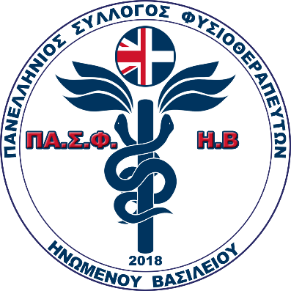18th October 2019, Athens

FROM: Panhellenic Physiotherapy Association of United

Kingdom

TO: European Region of the WCPT

**Subject: Clarifications and questions about the letter of WCPT secretary to the Greek minister of education**

Dear David Gorría,

On behalf of the Panhellenic Physiotherapy Association of United Kingdom and having read your urgent announcement concerning the proposed amendments to the regulation on the recognition of professional qualifications (Directive 36/2005), in the Hellenic Parliament we would like to inform you that:

The PSF (Panhellenic Association of Physiotherapists) during the past years has been meddling with the procedures for the recognition of professional qualifications of citizens who hold a U.K. degree.

In Greece, there are many institutions (Colleges) which have formed partnerships with British Universities and oﬀer U.K. degrees to Greek citizens. The Colleges have been approved by the Ministry of Education and are authorized to oﬀer these educational programs which are completely valid and identical to the programs that are offered in the U.K. Having qualified with such a degree the holder is able to register with the Health & Care Professions Council (HCPC) which is the regulator in the U.K. As a result, graduates can become full members of the Chartered Society of Physiotherapy (CSP) which is the professional, educational and trade union body for the UK’s Physiotherapists and work in the public or private sector across the U.K.

In order for a graduate to be able to work in Greece as a Physiotherapist, he has to recognize his qualifications or the equivalence of his degree through the appropriate council of the Ministry of Education (SAEP). It has to be noted that in the council of SAEP there is always a representative of the PSF. After this procedure, the holder of SAEP is able to submit an application in order to become a member of the PSF which is a prerequisite so as to acquire the license to practice the profession.

We would also like to inform you that every graduate who has already completed all of the aforementioned procedures is declined membership by the PSF, which is above and beyond its jurisdiction.

For more than 6 years that the SAEP exists, the PSF representative suspends the council or does not participate in the procedure in order for the council to be annulled. As a result more than 700 applications for recognition of qualifications or equivalence of degrees have been accumulated. Only a few holders of SAEP exist up to this day.(No more than 20 for the past 7 years).

Recently, in the last SAEP session the PSF representative blocked the procedure by canceling the meeting and the process of 40 applications which have been submitted more than 2.5 years ago. There are many applicants who have been waiting for more than 4 years.

It is clear that the PSF has been interfering with the process of the recognition of professional qualifications acting as a union which in our opinion is both illegal and unethical. At this point we’d like to clarify to you that the U.K physiotherapy degree holders now in Greece(with out the PSF registration-licence) are pretty much about a thousand .The law for the non E.U degree holders that is about to come includes this number.

Having informed you of the facts we would like to know your opinion on the issue and request your assistance in order for the matter to be resolved.We are able to submit any legal documents proving what has already been mentioned above if requested.

Yours sincerely,

Panhellenic Physiotherapy Association of United Kingdom